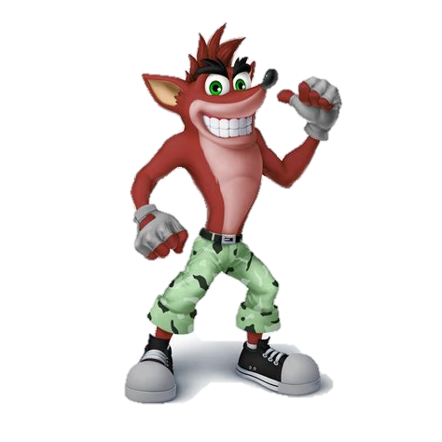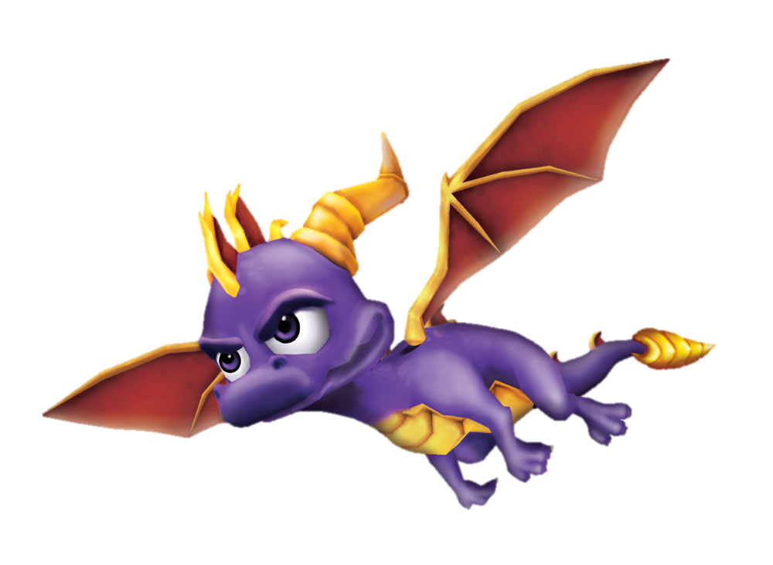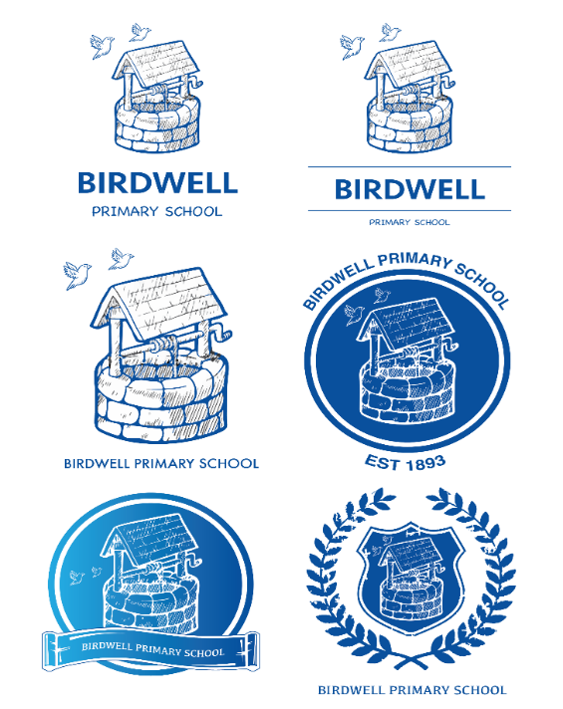

Unit 1 – Heroes and Villains

* Discuss existing computer game characters. Which are your favourites?
* Chn choose a character – create a timeline (**History**)
* (**Maths**) Sort characters using venn diagrams- heroes/villains, animals/people, magical powers/fantasy character
* Theme of LRRH- What would computer game version look like? We need characters
* **(DT)** Game designers make mock ups first- we’ll make a puppet. – Design your character
* Small groups marking, cutting and sewing to make a hand puppet
* (**English**) Write character descriptions of the computer game world
* (**Science**) 1. Identify everyday materials – what do we use each for? (Link with cont. natural/man made)

2. Find out how shapes of solid objects can be changed. (Dice game- start with body shapes)

3. Which materials would be best to use for LRRH’s cloak?

* (**English**) Write character descriptions.

Unit 2 – What a wonderful world!

* Explore a woodland setting a nature walk in school grounds. Role play a familiar story.
* (music) Create sound effects and record using the environment- twigs/leaves/bark
* (**DT**) Create a shoe box model of the setting. Y2 -Add a winding mech
* (ICT) – create a setting using a paint program.

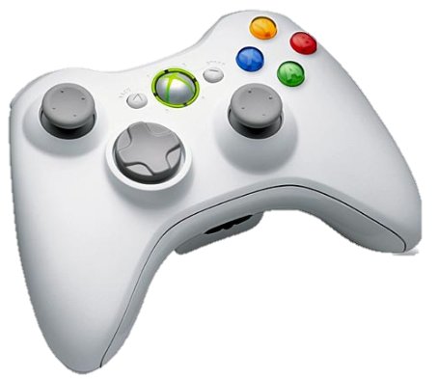

**Can you design a computer game?**

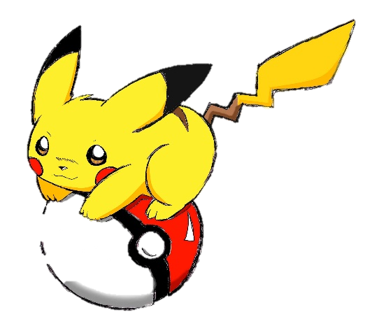

Unit 3 – Can you control it?

* (**Maths**) Control each other as robots by giving directions. Left/right, clockwise/anti-clockwise, forwards, backwards, turn, half turn, quarter turn, full turn.
* Practise programming and directional/positional language using bee-bots.
* (English) write instructions to direct a character around the map eg. From cottage to Grandma’s house (Then draw your own map).
* (ICT) Investigate algorithms through scratch.
* Edit/create own algorithms through scratch!
* Create a sprite to add to previously designed ‘world’.

